LABORATORY 4 (实验4)

Inheritance
继承

姓名: ___毛仁杰________ 学号: _____20181738______ 班级： 002

Objective(实验目的)
In this week’s lab you learn to create new objects using inheritance. Inheritance supports both abstraction and code reuse—two valuable programming techniques.
在本周的实验中你们将学习用继承的方法来创建新对象。继承能很好的支持抽象和代码重用——这是两个有价值的编程技术。

Key Concepts (相关概念)
_ Inheritance（继承）
_ Is-a relationship（is-a 关系）
_ Code reuse（代码重用）
_ Abstraction（抽象）
_ Base class（基类）
_ Derived class（派生类）
_ Derived-class declaration（派生类申明）
_ Derived-class implementation（派生类实现）

GETTING STARTED
Using the procedures in the introductory laboratory handout, create the working directory \cpplab on the appropriate disk drive and obtain a copy of archive lab4.rar. The copy should be placed in the cpplab directory. Execute the copy to extract the files necessary for this laboratory.
在电脑磁盘上创建目录\cpplab，将打包文件Lab4.rar解压到目录\cpplab下。

Many of the activities that are performed in the laboratory can be done in groups but you should work the exercises yourself.
实验中的许多练习可以分组做，但你自己应动手做练习。

INHERITANCE
A key feature of an object-oriented language is inheritance. Inheritance is the ability to define new classes using existing classes as a basis. Inheritance supports both abstraction and code reuse. For example, suppose you were going to develop classes for different kinds of bicycles. You might develop classes to represent mountain bicycles and road-racing bicycles. It may pay off to introduce a base class that contains the features common to all types of bicycles and to then use the base class to create specialized types of bicycles. Furthermore, this type of hierarchical abstraction of common features helps you understand the classes. For example, even if you do not know exactly what a hybrid bicycle is, because it is a bicycle, you know it must have two wheels, handlebars, and pedals.
继承是面向对象语言的一个关键特性。继承具有利用现有的类为基础来定义新类的能力。继承支持抽象和代码重用。例如,假设你打算开发几个类来表示不同的自行车。你可能会用类来代表山地自行车和赛车。较好的方法是引入一个基类来包含所有类型的自行车共同特征，然后使用基类来创建特别类型的自行车。此外,这种类型层次抽象的共性特征可以让你理解类。比方说,即使你不知道到底是何种衍生的自行车,因为它是一辆自行车,你就知道它必须有两个轮子,把手,踏板。

The relationship between a mountain bike and a generic bicycle is known as an is-a relationship—a mountain bike is a bicycle. The relationship between a bicycle and its wheels is a has-a relationship—a bicycle has wheels.
山地自行车与普通自行车的关系被视为一种is-a关系，一辆山地自行车是一辆自行车。自行车和车轮就是有一种has-a关系，凡是自行车都得要有轮子。

An inheritance hierarchy is often presented pictorially. For example, the inheritance hierarchy of the EzWindows shapes is
继承层次通常都用图来表示。如图是EzWindows库中形状的继承层次。
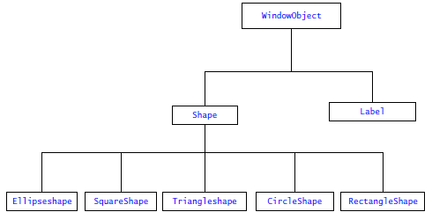

We see that the base class is WindowObject and that the classes Shape and Label are derived from WindowObject. Thus a Shape is a WindowObject, and a Label is a WindowObject.
我们看到,基类是WindowObject，Shape 和 Labe类都源自WindowObject。这样Shape是一种WindowObject, Label也是一种WindowObject。

Designing an inheritance hierarchy is one of the keys to a good object-oriented design.
设计继承层次是一个良好的面向对象设计的关键之一。

Developing a flexible hierarchy is quite difficult, but in the long run, it can pay off by reducing both maintenance costs and future development costs.
开发一个灵活的层次是非常困难的,但从长远来看,它可以降低维护成本和未来开发成本。

To get a feel for developing a hierarchy of objects based on the is-a relationship, develop an inheritance hierarchy for telephones. For each class of telephone in your hierarchy, give the attributes and behaviors of the class.
感受一下开发一个基于is-a继承关系的具有继承特性的对象,开发出一具有is-a继承关系的电话。在每个电话类中,给赋予属性和行为。
✎

THE MECHANICS OF INHERITANCE

Open the file rect.h. Examine the RectangleShape class declaration.
Answer the following questions.
打开rect.h文件。检查RectangleShape类声明。回答下列问题。

— What is the base class for RectangleShape?
— RectangleShape的基类是？
✎Shape

- Suppose a user defines a RectangleShape object name R. Determine all the messages that a client user can send R. That is, what member functions of R can a client user invoke?
- 假设定义了一RectangleShape对象，名为R。指出所有可由用户发送给对象R的信息，即用户可以调用对象R的哪些成员函数?
✎float GetWidth() const;
float GetHeight() const;

void GetSize(float &Width, float &Height) const;
void SetSize(float Width, float Height);

void Draw();
void Erase();

Show your answers to a laboratory instructor.
把你的答案给指导老师看看。

Open the file rect.cpp.
打开文件rect.cpp。

Examine the constructor for RectangleShape. What constructors in the Shape inheritance hierarchy are called to instantiate a RectangleShape?
检查RectangleShape的构造函数。在Shape继承层次中什么构造函数被调用来实例化一个RectangleShape对象?
✎
Shape(Window,
Position(XPosition, YPosition), c)

To verify your answer, open the project file exp1.sln. For each constructor in the shape inheritance hierarchy, add an insertion statement such as
核对你的答案，打开项目文件exp1.sln。在Shape继承层次中, 为每个构造函数增加一条标准输出的插入语句，如
cout << "Constructor XXX called" << endl;
where XXX is the name of the constructor. Hint: Use the IDE’s cut-and-paste feature to add the insertion statement. Run the program and write down the order in which the constructors were called._
这里的XXX是构造函数的名称。提示:使用IDE复制功能,增加插入语句。运行该程序,然后写下构造函数的调用顺序。
✎
Constructor Shape called
Constructor RectangleShape called
先调用基类构造函数在调用派生类构造函数

Close the project exp1.sln.
关闭项目文件exp1.sln

SHADOW BOXING
A useful type of window object is a shadowed rectangle.
一种有用的窗口对象是一种带阴影的矩形。
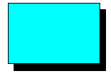
Shadowed rectangles have a three-dimensional look. We can create this new type of window object easily using inheritance.
有阴影的矩形具有三维的观感。我们使用继承能轻易创造这种新型的窗口对象。

We will call this new shape ShadowedRectangleShape. The class ShadowedRectangleShape will be derived from RectangleShape. This is saying that a ShadowedRectangleShape is a kind of RectangleShape. For this exercise, a ShadowedRectangleShape will be identical in all respects to a RectangleShape except that when a ShadowedRectangleShape is drawn a black shadow is included. The shadow is offset 0.25 centimeters to the right and below the main rectangle.
我们将称这个新的形状为ShadowedRectangleShape。类ShadowedRectangleShape由类RectangleShape派生而来。也就是说ShadowedRectangleShape是一种RectangleShape。在这个练习中, ShadowedRectangleShape和RectangleShape在所有方面将是相同的, 除了当画一个ShadowedRectangleShape时，多了一个黑色的阴影。这个阴影向主矩形的右下方偏移0.25厘米。

Create the class declaration for ShadowedRectangleShape in the file shadowrect.h. You may find it helpful to look at rect.h. If you need help ask your laboratory instructor.
在文件shadowrect.h中为ShadowedRectangleShape创建类声明。查看rect.h文件或许有些帮助。如果你需要帮助，可问你的实验指导。

Next implement ShadowedRectangleShape. Place the implementation of ShadowedRectangleShape in the file shadowrect.cpp. Again you will find it useful to use rect.cpp as a guide. Indeed, besides the constructors only the Draw() and Erase() member functions need to be implemented—all the other member functions are inherited.
下一步来实现ShadowedRectangleShape。将ShadowedRectangleShape的实现放到shadowrect.cpp中。你会再一次发现参考rect.cpp会很有用。事实上,除了构造函数只有Draw()和Erase()需要扩充 —— 所有其他成员函数都是继承的。

Open the project file exp2.sln. Examine the program exp2.cpp. Demonstrate that your implementation of ShadowedRectangleshape works to the laboratory instructor. _
打开项目文件exp2.sln。检查程序exp2.cpp。将你的ShadowedRectangleshape的实现给实验指导老师演示。(将绘制有阴影矩形的窗口截图粘贴在下面)
✎看不懂Erase（）里面2个if的定义
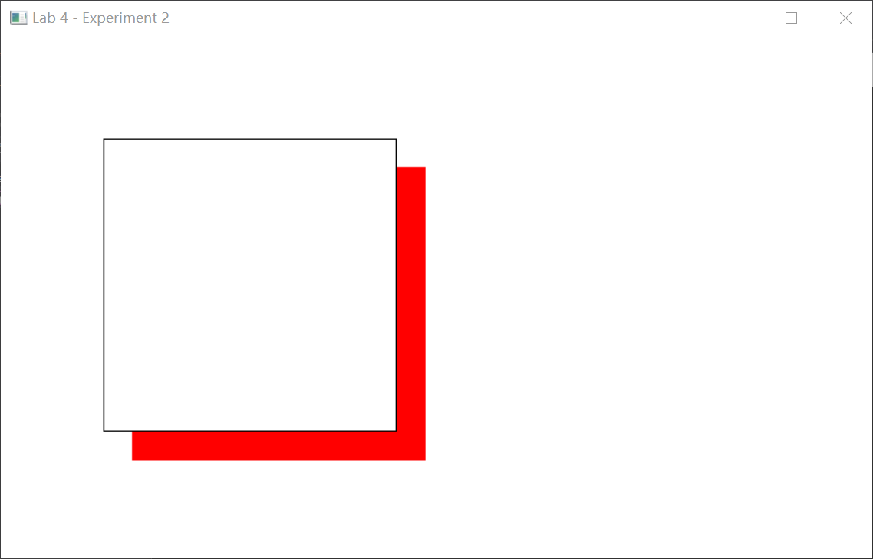
Close the project exp2.sln.
关闭项目文件exp2.sln。

DON’T GET BOXED IN
Another handy type of window object is a box. As the following picture shows, a box is like a rectangle with no borders except that its middle is empty.
另一个好用的窗口对象类型是盒子。如下面图片所示, 一个盒子就像一个无边框的长方形挖去中间的部分一样。

_ Using the existing shape hierarchy and inheritance, it is easy to build a new box object. Design a simple box class. Your box class should be derived from Shape. (A box is not a kind of rectangle). In this BoxShape class, the walls of the box are always 0.3 centimeters thick. Before writing any code, answer the following questions.
利用现有的形状继承层次, 比较容易建立一个新盒子对象。设计一个简单的盒子类。你的盒子类应该来派生于Shape。(一个盒子不是一种RectangleShape)。在这个BoxShape类中，这个盒子的墙壁总是0.3厘米厚。在写任何代码前，回答下面的问题。

- What member functions, if any, are specific to BoxShape?
- 什么成员函数，如果有的话，对BoxShape是特别的？
✎
Draw()
Erase()

- What data members, if any, are specific to BoxShape?
- 什么数据成员，如果有的话, 对BoxShape是特别的？
✎
Offset

- Describe how you will draw a BoxShape.
- 描述你将怎样画你的BoxShape？
✎
先画大的无框矩形，再在中间画小的无框矩形

Open the project file exp3.sln.
打开项目文件exp3.sln。

Open the include file box.h. This file should be empty except for a comment. In this file, add your class declaration for BoxShape. If you are unsure how to declare the class, you may find it helpful to examine the declaration of RectangleShape in rect.h. Save the declaration of BoxShape in the file box.h.
打开box.h文件。这个文件应该是空的,除了一个注释。在这个文件中，加上你的BoxShape类声明。如果你不知道如何声明这个类, 研究rect.h中RectangleShape的声明会对你有帮助。保存BoxShape的声明到文件box.h中。

Explain your BoxShape class declaration to a laboratory instructor.
给实验指导解释你的BoxShape类声明。
Open the file box.cpp. Again, this file should be empty except for a comment. In this file, type in the implementation of the constructors and member functions for BoxShape. If you are unsure how to implement the BoxShape’s constructor, you may find it helpful to examine the constructor for RectangleShape in rect.cpp.
打开box.cpp文件。这个文件中除了有一个注释外，应该还是空的。在该文件中，输入你写的BoxShape类的构造函数和成员函数。如果你不知道如何实现BoxShape的构造函数时,你可以参考在rect.cpp中的RectangleShape的构造函数。

Save the implementation of BoxShape in the file box.cpp.
保存BoxShape 的实现到文件 box.cpp中

Explain your implementation of BoxShape to a laboratory instructor.
把你的实现解释给实验室指导员。

Open the file exp3.cpp. This file contains a stub for the function ApiMain(). (A stub is a function where the body of the function has been omitted). A stub allows the program to be compiled, but the function does not do anything when called.
打开文件exp3.cpp。该文件包含一个stub的ApiMain()函数。(一个stub是一个函数体内容为空的函数)。stub允许一个程序编译成功,但当调用时什么都不做。

To demonstrate the use of BoxShape, add code to the function ApiMain() that creates a diagram as shown below:
为了验证BoxShape的使用, 对ApiMain函数增加代码，绘制出如图所示的效果:
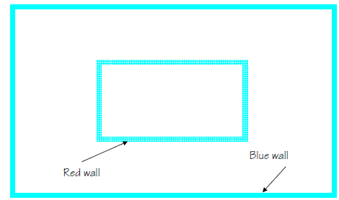

Demonstrate your program to a laboratory instructor.
把程序展示给实验指导。（提交exp3.cpp 和box.cpp文件）
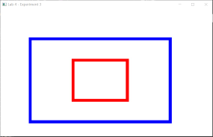
You can make BoxShape more flexible if you permit the user of a BoxShape to specify the thickness of the walls of the box when it is created. Modify box.h and box.cpp to include this extension.
你能使BoxShape更灵活，如果你允许用户创建对象时指定BoxShape壁厚度。修改box.h和box.cpp可进行扩展。

Demonstrate that your extension works correctly by modifying exp2.cpp so the walls of the outer box are 1 centimeter thick, and the walls of the inner box are 0.5 centimeters thick. The outer box is blue and is 10 centimeters by 6 centimeters. The inner box is red and is 4 centimeters by 3 centimeters. The window your program creates should look something like the following:
通过修改exp2.cpp可使你的扩展正确运行。外箱是1厘米厚、内箱是0.5厘米厚。外框是蓝色的,宽6厘米，长10公分。内箱是红色的,4厘米*3厘米。你的程序创建窗口应该看上去如下:

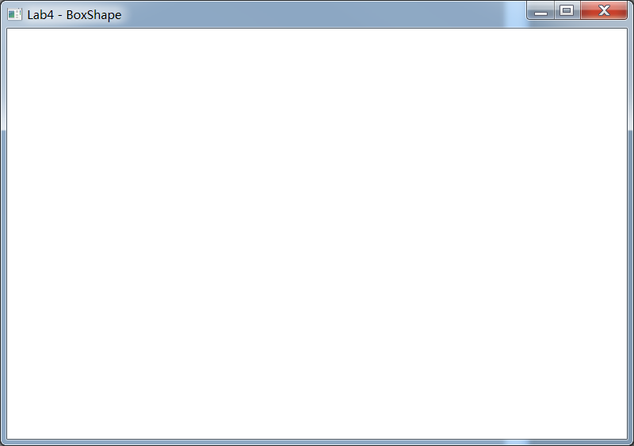

Demonstrate your program to the laboratory instructor.
把程序展示给实验室指导员。（提交exp2.cpp文件）
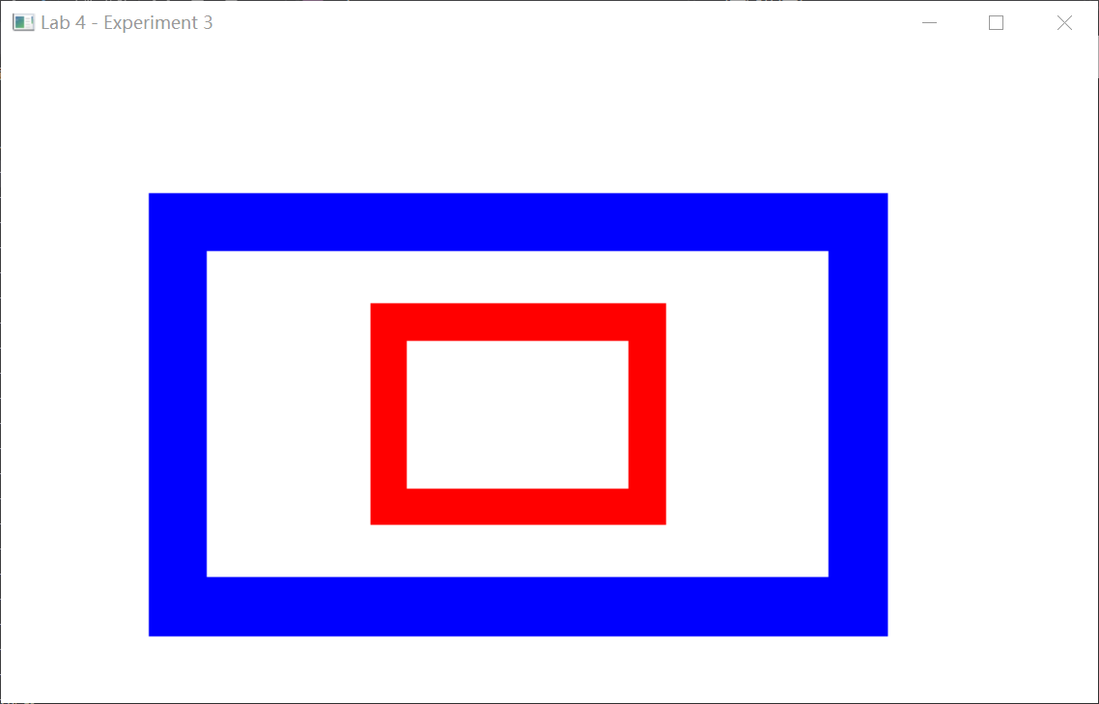
Close the project exp3.sln.
关闭项目文件exp3.sln.

FINISHING UP
Copy any files you wish to keep to your own drive.
拷贝你想保存的文件到自己的硬盘中。

Delete the directory \cpplab.
删除目录\cpplab。

Hand in your check-off sheet and program.
递交实验报告和程序

